

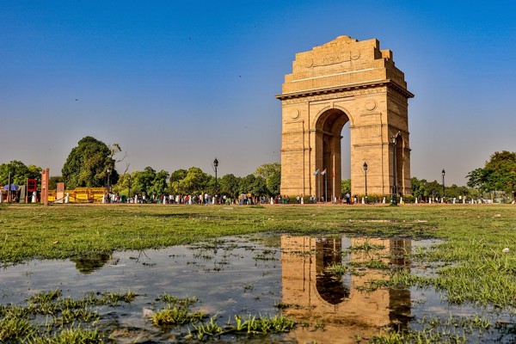

**Day 1: Arrival in Delhi - Exploring the Capital**

Travel Time Distance: Local transit within Delhi, minimal travel.   
Welcome to Delhi! After settling in, we'll visit the iconic India Gate. Enjoy a leisurely afternoon exploring Connaught Place for shopping and local eateries. In the evening, we’ll stroll through the beautiful gardens of Lodi, soaking in the vibrant atmosphere. Don’t miss the nearby historic tombs! Dine at a local restaurant to savor Delhi’s famous street food.  
  
---